|  |  |
| --- | --- |
| Subject: Data Analytics and Visualization Lab | Course ID: CSL-601 |
| Semester: VI | Course: AI & DS |
| Laboratory: 407 | Name of teacher: Prof. Gitanjali Korgaonkar |
| Name of Student: Ayush Gupta | Roll No: VU2S2324001 |

**EXPERIMENT NO. 7**

**Aim:**

To understand and implement Multiple Linear Regression.

**Theory:**

Multiple Linear Regression is a statistical technique that models the relationship between a dependent variable and two or more independent variables. Unlike simple linear regression, which deals with only one predictor variable, multiple linear regression can analyze and quantify the contribution of each predictor variable to the dependent variable.

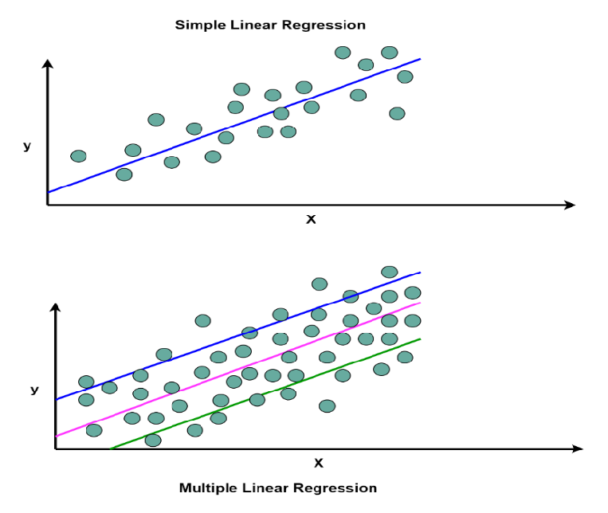

**Mathematical Representation of Multiple Linear Regression:**



where:

* y is Dependent Variable (Target)
* x1, x2, …., xp are Independent Variables (Feature)
* β0​ is Intercept (value of y when x = 0)
* β1, β2, …., βp​ are the Regression Coefficients (Slope)
* ε is Random Error

**Assumptions of Multiple Linear Regression:**

1. **Linearity:** The relationship between the independent and dependent variables must be linear.
2. **No Multicollinearity:** Independent variables should not be highly correlated.
3. **Homoscedasticity:** The variance of residuals should be constant across all values.
4. **Independence of Observations:** The residuals should be independent of each other.
5. **Multivariate Normality:** Residuals should be normally distributed.

**Algorithm:**

1. Load the dataset containing multiple independent variables and one dependent variable.
2. Split the dataset into independent variables (X) and dependent variable (y).
3. Train the model using a linear regression algorithm.
4. Extract model parameters, including coefficients and intercept.
5. Use the trained model to make predictions.
6. Evaluate model performance and visualize the results.

**Flowchart for Simple Linear Regression:**

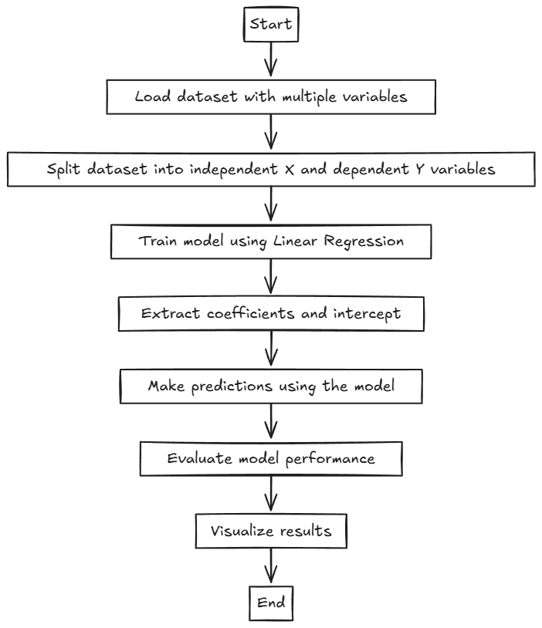

**Learning Outcomes:**

* Understand the concept and importance of Multiple Linear Regression.
* Learn how to implement Multiple Linear Regression in Python and R.
* Gain insights into regression coefficients and their impact.
* Learn how to evaluate model performance using predictions.
* Understand the visualization of regression results in a 3D space.

**Conclusion:**

Multiple Linear Regression is a powerful statistical technique that enables the prediction of a dependent variable based on multiple independent variables. It is widely used in finance, economics, and machine learning applications. By implementing Multiple Linear Regression in both Python and R, we have demonstrated its ability to identify relationships between variables and make accurate predictions. The visualization of the regression model helps in understanding the influence of independent variables on the dependent variable.

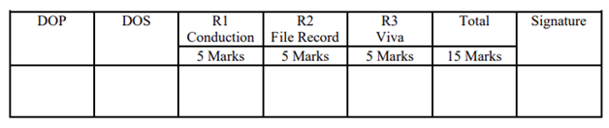

**Program and Output:**

* 1. **Multiple Linear Regression in Python:**

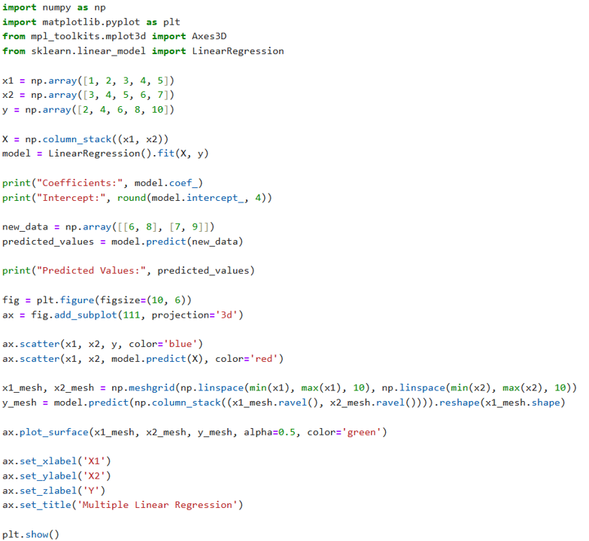

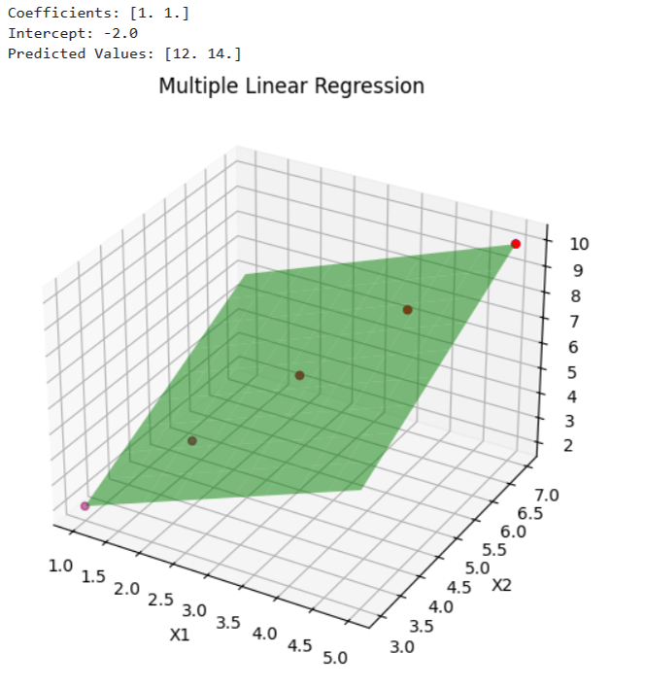

* 1. **Multiple Linear Regression in R:**

